FreeRTOS kernel source code download Link
In Link got to “FreeRTOS 202212.01” and click on “Download”

What is Real Time application
Ans: Real Time computing is equivalent to Pridictable computing.

Real Time deals with guarantees
Time is more important.

A real-time system is one in which the correctness of the computation depends not only on the logical correctness of the computation but also on the time at which the results are produced. If the timing constraints are not met, system failure is said to have occurred.

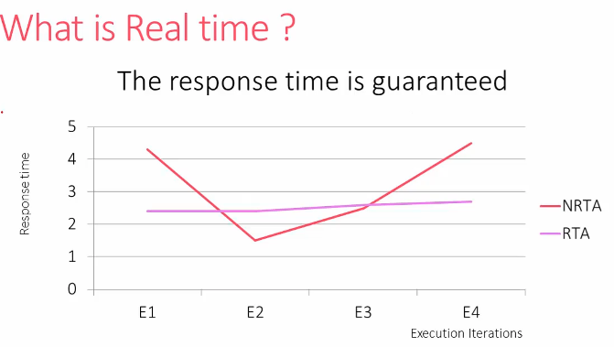

Real time applications
- Not Fast executing applications
- Time-deterministic application means their response time to event is almost constant
- Small deviation in RTA’s response time in ms/s, which is soft real-time applications
- Hard Realtime must complete within a given time limit; failure to do so will result in absolute failure of the system.

Hard Realtime example
- Airbag deployment
- Anti-Lock Breaking
- Missile guidance & control systems

Soft Realtime example
- VOIP
- Stock Market

What is RTOS?
Its OS, specially designed to run applications with very precise timing & a high degree of reliability.

Throughput: The total number of processes that complete their execution per unit time

GPOS designed to have high throughput

Systick timer only for RTOS
For others timers we can use other controller sources./

Local Variable in Task is stored in stack memory of the task and each task have the copy of this variable
If Local variable in task is declared as static then it will be treated as global variable and have only one variable which is shared variable between tasks if one task is created multiple times and this can be stored in RAM memory. Stored in global area of RAM also called .DATA section.

BaseType_t xTaskCreate( TaskFunction_t pvTaskCode,
const char * const pcName,
const configSTACK_DEPTH_TYPE uxStackDepth,
void *pvParameters,
UBaseType_t uxPriority,
TaskHandle_t *pxCreatedTask
);

- pvTaskCode
Pointer to the task entry function (just the name of the function that implements the task, see the example below). Tasks are normally implemented as an infinite loop; the function which implements the task must never attempt to return or exit. Tasks can, however, delete themselves.
- pcName
A descriptive name for the task. This is mainly used to facilitate debugging, but can also be used to obtain a task handle. The maximum length of a task's name is defined by configMAX_TASK_NAME_LEN in FreeRTOSConfig.h.
- uxStackDepth
The number of words (not bytes!) to allocate for use as the task's stack. For example, if the stack is 16 bits wide and uxStackDepth is 100, then 200 bytes will be allocated for use as the task's stack. As another example, if the stack is 32-bits wide and uxStackDepth is 400 then 1600 bytes will be allocated for use as the task's stack. The stack depth multiplied by the stack width must not exceed the maximum value that can be contained in a variable of type size_t. See the FAQ How big should the stack be?.
- pvParameters
A value that is passed as the paramater to the created task. If pvParameters is set to the address of a variable then the variable must still exist when the created task executes - so it is not valid to pass the address of a stack variable.
- uxPriority
The priority at which the created task will execute. Systems that include MPU support can optionally create a task in a privileged (system) mode by setting the bit portPRIVILEGE_BIT in uxPriority. For example, to create a privileged task at priority 2 set uxPriority to ( 2 | portPRIVILEGE_BIT ). Priorities are asserted to be less than configMAX_PRIORITIES. If configASSERT is undefined, priorities are silently capped at (configMAX_PRIORITIES - 1).
  - Higher the value have higher priority, and vice versa.

- pxCreatedTask
Used to pass a handle to the created task out of the xTaskCreate() function. pxCreatedTask is optional and can be set to NULL.
Returns:
- If the task was created successfully then pdPASS is returned.
- Otherwise errCOULD_NOT_ALLOCATE_REQUIRED_MEMORY is returned.

Word: Its an max size of the data which can be accessed by the processor in a single clock cycle.
Word size depends on processor design (bus)
For ARM Cortex Mx based microcontroller wored size is = 32 bits (4 bytes)
So stack is 32 bit, uxStackDepth is assigned to 400, then Task stack size allocated is 400*4(which is 32bit = 4bytes) = 1600 bytes

configSTACK_DEPTH_TYPE
Sets the type used to specify the stack depth in calls to xTaskCreate(), and various other places stack sizes are used (for example, when returning the stack high water mark).
Older versions of FreeRTOS specified stack sizes using variables of type
UBaseType_t -
, but that was found to be too restrictive on 8-bit microcontrollers.
configSTACK_DEPTH_TYPE - Defined in FreeRTOS.h
 removes that restriction by enabling application developers to specify the type to use.

UBaseType_t usStaDepth -> uint8_t usStaDepth (8bit MCU - Max data stored is 255 bytes)
configSTACK_DEPTH_TYPE usStackDepth

#defined configSTACK_DEPTH_TYPE uint16_t (defined in FreeRTOS.h - can be modified any time.)

Scheduling

2 Task created (in READY state)
We neeed to invoke the scheduler using below API
Task will be dispatched to run on the CPU
Scheduler is pice of code part of FreeRTOS kernel, which runs in privilege mode
We neeed to invoke the scheduler using below API
Scheduling policies
- Pre-emptive scheduling
  - configUSE_PREEMPTION = 1
  - Preemption is replacing a running task with another task
  - Force running task to give up and schedule another task (Replacing the current task with another task)
  - Context switch tasks place after time interval by using defined macro in FreeRTOSConfig.h
    - #define configTICK_RATE_HZ ( (TickType_t) 1000 )
    - Here 1000 means 1 milliseconds, At every 1 milliseconds scheduler will perform context switching and another task will come in running state.
  - 2 Types
    - Round Robin (cyclic)
      - Task runs for a specific time and reschedules another task to the running state, which means it makes the previous task from running state to
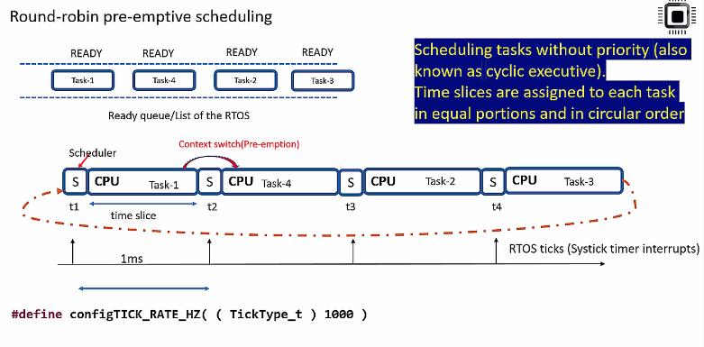

    - Priority based

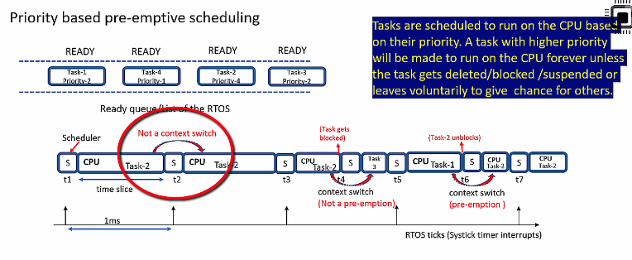

- Co-Operative scheduling
  - configUSE_PREEMPTION = 0
  - There is no prementation
  - At RTOSTick is present, and every time scheduler dosent runs
  - Scheduler runs if task is running. If task gets completed scheduler will not come in picture and directly starts another task.
  - Taks performs yielding
- Printf works on SWO pin of processor.
  - Printf sends message to ITM (Instrument Trace Macrocell)
  - Need to include the code for the same.
  - In Document: https://github.com/niekiran/Embedded-C/blob/master/All_source_codes/target/itm_send_data.c
  - Add above link code in Src-> syscalls.c file
  - Update Write function as shown in below details
    - __attribute__((weak)) int _write(int file, char *ptr, int len)
    - {
    - (void)file;
    - int DataIdx;
    - for (DataIdx = 0; DataIdx < len; DataIdx++)
    - {
    - //__io_putchar(*ptr++);
    - ITM_SendChar(*ptr++);
    - }
    - return len;
    - }
To debug the code in board follow below steps

Open .ioc file -> goto Clock configuration -> Check “FCLK Cortex clock (MHz)”. This is clock speed in your system.

Right click on Project Name-> Debug As -> STM32 C.. as shown in below image
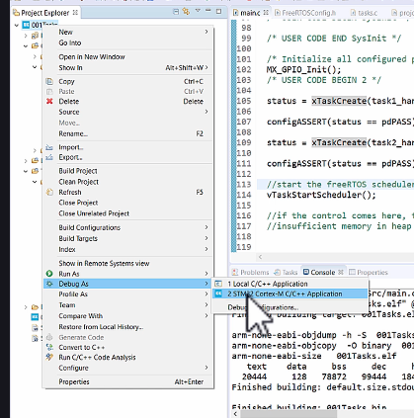
Then Goto Debugger-> In Interface section enable SWD (Serial Window Debugger) -> Then scroll down and enable Serial Wire Viewer (SWV)
Set Core Clock to Number in above clock configuration value.
Then click Apply and then ok.

Open Serial wire viewer as shown in below images

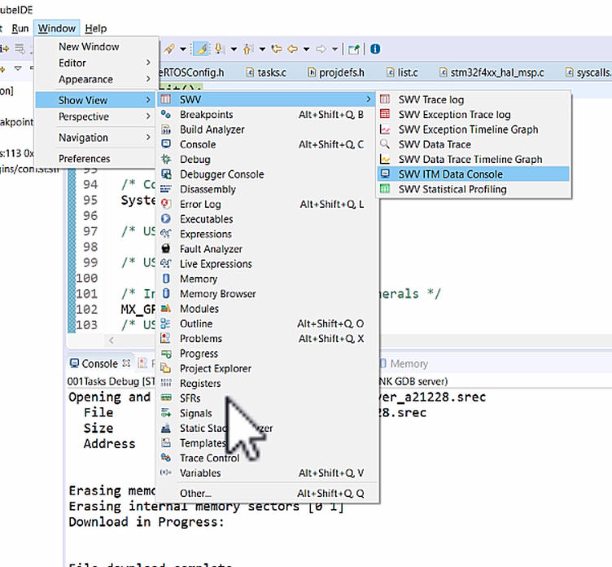

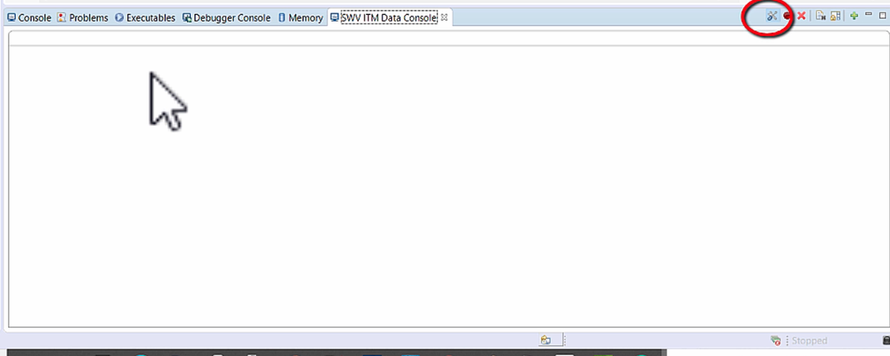

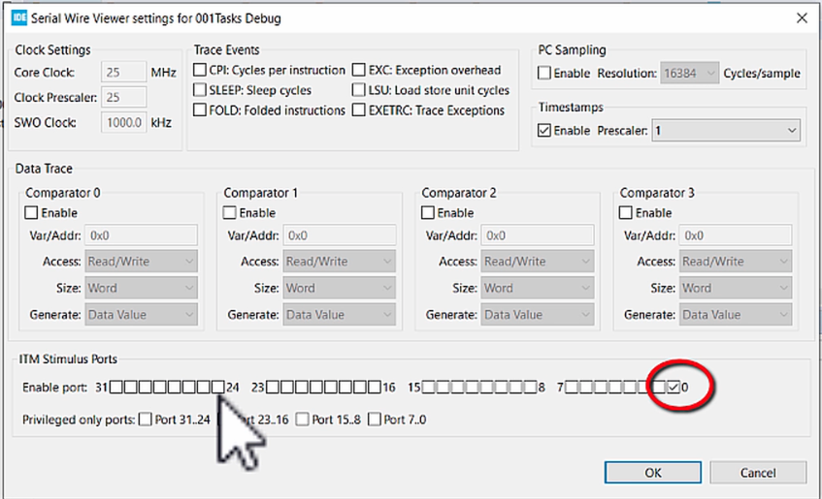
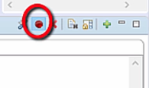

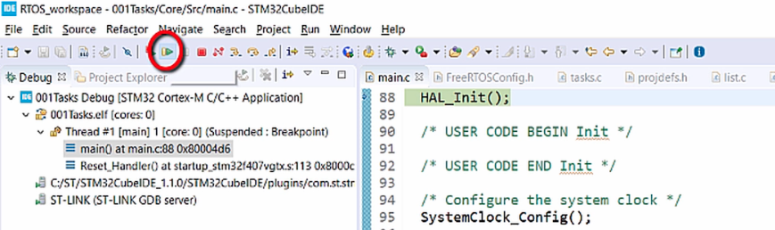

Heap memory for project is configured in FreeRTOSConfig.h with updating below macro

#define configTOTAL_HEAP_SIZE ( ( size_t ) ( 75 * 1024 ) )

#define configTOTAL_HEAP_SIZE ( ( size_t ) ( HEAP_Value * 1024 ) )

To update HEAP_Value below points need to known.
- Need to know how much RAM is used in out project

2 stack pointers are available in STM32
- PSP - Process Stack pointer
- MSP - Main Stack pointer

Heap memory can be managed using heap4.c in the MemMang folder

/* Allocate the memory for the heap. */
#if ( configAPPLICATION_ALLOCATED_HEAP == 1 )
/* The application writer has already defined the array used for the RTOS
* heap - probably so it can be placed in a special segment or address. */
extern uint8_t ucHeap[ configTOTAL_HEAP_SIZE ];
#else
PRIVILEGED_DATA static uint8_t ucHeap[ configTOTAL_HEAP_SIZE ];
#endif /* configAPPLICATION_ALLOCATED_HEAP */

